Willetton PS BYO iPad Program 2024
These are exciting educational times for our children as they share, develop and communicate using available Information and Communication Technologies (ICT). Students today need the knowledge, skills and confidence to make ICT work for them in school and beyond. Moreover, students will need to be highly skilled in using the technologies to build towards higher or more advanced learning.

Expectations of the National Australian Curriculum
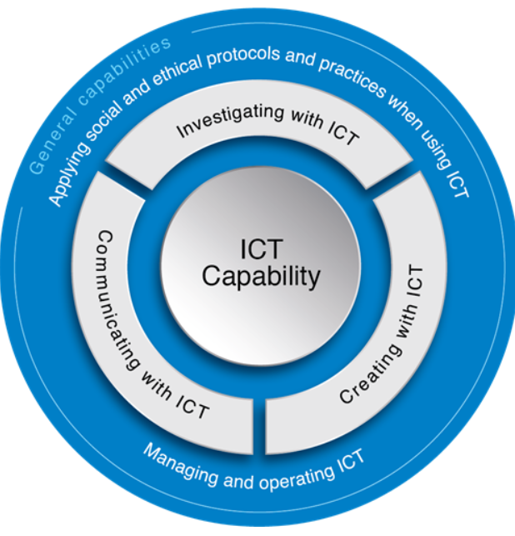
Under the Western Australian Curriculum, it is expected that students learn to use ICT effectively and appropriately to access, create, and communicate information and ideas, solve problems and work collaboratively in all learning areas at school.
Together, the teachers and School Board have strongly supported the introduction of a 1:1 iPad program since it’s inception in 2015. 1:1 programs assist us to individualise learning, which can increase independence and self-initiated learning in students, and extend their learning beyond the classroom.

what is a byod program?
BYOD programs are also known as 'anywhere, anytime' programs. These programs provide students with personal portable computers to enhance opportunities for learning. The devices help nurture individual learning experiences.
In the past few years, a broad range of schools in Western Australia have chosen to introduce BYOD laptops or tablets. These programs mean that every child in particular year levels has a parent funded (via lease or purchase) laptop/tablet that is used by the student at school as a tool to support their learning. In all cases, these programs have been introduced after careful consideration by the school and engagement with the school community.

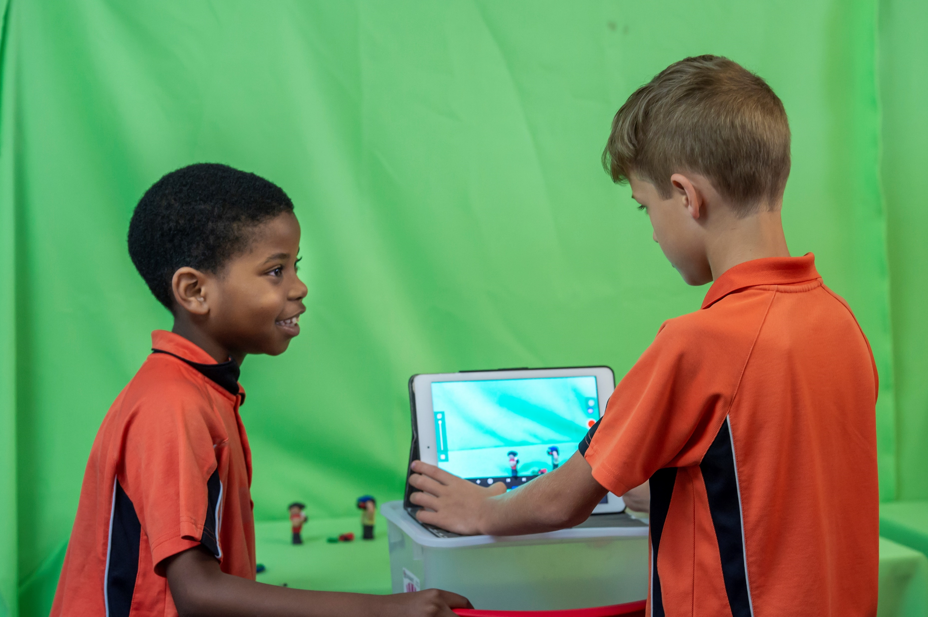
Why introduce this program in year 3?
Year 3 represents smaller class numbers before moving into middle schooling. Students at this age of learning typically develop:
- a greater ability to work independently and collaboratively
- 3 years of explicit digital technology education prior to Year 3
- learn from a wider range of sources
- explore a wider range of technologies and show deeper reflection on their learning and goal alignment. The children will use the selected device for Years 3, 4, 5 and 6.

Why iPADS for primary school students?
iPad and Apple programs are now common across WA schools. Willetton PS has been implementing a BYO iPad school program for a couple of years. Each year our program has developed to a higher level as staff and students become more skilled in the use of iPads. Willetton PS selected iPads as our primary device for many reasons. The varied apps available on an iPad provide teachers with the opportunity to deliver higher quality, technology driven curriculum lessons. iPads provide continuity across the years and using the single Apple iPad platform, allows us to consistently manage our network effectively.

Why Apple?
- Stability - The iPad operating system has the reputation of being robust and intuitive.
- Security – The Apple Store is safer because Apple takes enough time in reviewing an app and then making it available to users. Apple tests all new apps before releasing them to the public, ensuring no inappropriate content appears. It’s the key principle behind the App store’s high-quality standard. Every app reaching here is carefully reviewed and then receives a rating from the Apple.
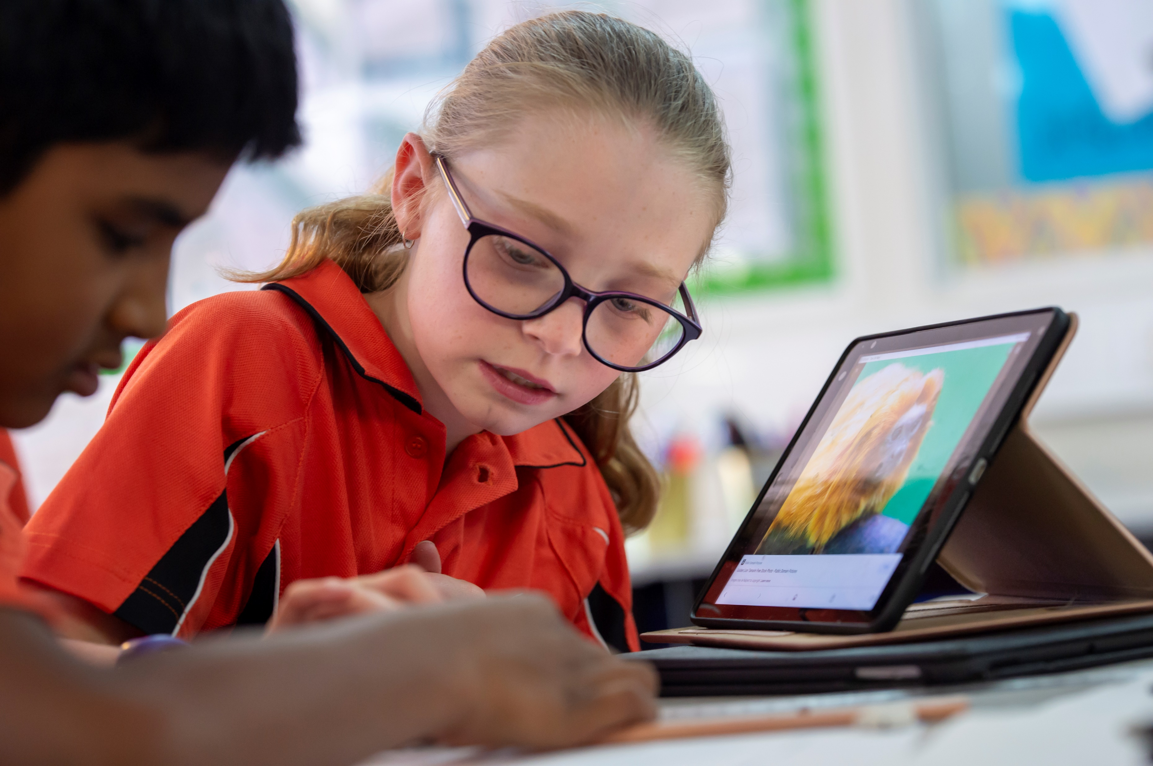
- Continuity - Apps perform the same way on all recent versions of the iPad, making it easier to cater for a variety of devices over time. Apple updates are pushed through automatically, once they are downloaded, ensuring users are consistently using the most up to date versions of the software. The Apple ID system allows users to change devices without losing any apps.
- Support - The AppleCare Protection Plan provides 24/7 complimentary telephone support, including software support for 2 years. AppleCare gives you one-stop technical service and support from Apple experts and most issues can be resolved in a single call. You will need to purchase AppleCare separately to access this cover.

What if I don’t provide an iPAD?
The iPad program is completely voluntary. Students who do not have their own device will have limited access to school technology such iPads and laptops. The Junior Primary cluster has a large bank of iPads for use with Years 1 to 2 classes provided by the school and the pre-primary cluster have a their own bank for Kindy and Pre-primary student use. These are unavailable as they are being used constantly in the junior classes to build the junior students knowledge and technology skills to prepare them for the BYO iPad program in Year 3.

What iPAD should I buy?
We recommend devices compatible with iOS17 and 32GB upwards such as:
iPad Pro (all generations), iPad (6th – 10th generation), iPad Air (4th and 5th generation), 32 GB as the minimum device required. iOS Information available here: https://www.apple.com/ipados/
- The newer the iPad, the longer it will be able to accommodate future software and app purchases.
- The technology available on new versions of the iPad is of greater capacity and quality than previous devices. If your iPad is compatible with the newest operating system iPad OS then you will be able to use features like Files: saving to places file servers or external drives, easier text editing and slide over and split view for easier multi-tasking between apps.
- Choosing one of the recommended iPads listed above will give Airdrop and Airplay function for everyone as well as access to all apps required for use at school.

What iPAD shouldn’t I buy?
- iPad Mini – these devices are not supported by the Department of Education for use online and with Naplan Online.
- Anything less than 32GB – The recommended size for an iPad in an educational environment is at least 32GB. Students will require this as a minimum to allow them to store and save work on their device. Items stored on the iPad include apps, photos, videos and other media. 32 GB or bigger enables students to store their work on the device without having to manage the content externally. It allows the flexibility for home and holiday use by your family. Many families buying iPads with less storage space are finding the device fills quickly and requires management and data transfer in order to keep the device functioning as intended.

Where should I get my child’s iPad from?
There are a number of options you may wish to consider in regard to providing your child with an iPad:
- If your family already has an iPad and you would like to send this to school with your child, you do not need to purchase a new device at this time – providing it is capable of operating with the required capacity as listed above.
- You may wish to purchase or lease a new iPad for your child.
Wherever you purchase your device we recommend you consider the AppleCare Protection Plan which provides 24/7 online support and ensure your device is insured.

What ELSE DO I NEED TO BUY?
When you purchase your iPad, you will need to consider the following:
- Your iPad must be fitted with a protective case, front and back. Keep in mind the students will be using them to take photos and videos so ensure the cover can be held or moved to allow easy access. If you purchase or lease your device through the Winthrop Australia portal, you may select a cover as an optional accessory.
- We strongly encourage students to purchase a keyboard to use with their iPad. This will support them in the development of vital typing skills in preparation for higher education. Keyboard options are available through Winthrop, however, any keyboard is suitable.
- All Apple hardware comes with a one-year limited warranty and up to 90 days of complimentary telephone technical support. It is recommended you extend your coverage further with the AppleCare Protection Plan. If you purchase your device through the Winthrop Australia portal you may select the 2 Year iPad AppleCare Protection Plan as an optional extra.
Your iPad is not covered by Willetton Primary School or Department of Education insurance policy. You may wish to check with your home and/or contents insurer to ensure your existing cover extends to an iPad being brought to school by your child. If you purchase your device through Winthrop Australia you may select insurance through ProtectSure as an optional extra.

Security - Before, after and during school
- The security of the iPad is the responsibility of the parent/carer outside of school hours.
- Students are not allowed to remove iPads from classrooms during lunch or recess. At these times the iPads will be secured in the classroom.

What happens if my iPAD is not functioning properly?
Whilst the school will do its best to support and troubleshoot any issues that do arise we are not able to resolve issues, particularly hardware.
If you purchase or lease your ipad through Winthrop Australia and you have a 2 year AppleCare Protection Plan with 24/7 technical support, your first option would be to access the support provided by the apple experts through applecare.
If you purchase your iPad independently or provided one from home you will need to refer to the warranty you selected at the point of sale. Apple products have a 1 year limited warranty unless you purchase an AppleCare Protection Plan which provides a 2 year warranty

